Biology 115D 2023

**Evolution, Behavior, & Ecology Exam #2**

**Name (printed) _____________________________________**

**This work was completed in accordance with the Austin College academic integrity policy. _______________________ (signature)**

° Read each question carefully.

° If a question appears ambiguous, ask for clarification.

° Keep an eye on the clock. Do not get bogged down on difficult questions when relatively easy questions remain to be answered. Do not leave an essay entirely blank. One or two sentences may earn a substantial amount of credit.

° Write legibly and try to confine your answers to the space provided. If you must have more space, continue on the back of the last page – but indicate that you have done so.

° Think before you write. Check your essays to make sure they say what you mean and that they are as clear and precise as possible.

1. Describe three major events in the history of life on earth that occurred before the asteroid impact that led to the extinction of dinosaurs. (12 points)

2. Describe three factors that cause average annual precipitation and average annual temperature to vary from place to place around the planet. Be sure to explain the effect of each factor and why it has that effect. (12 points)

3. Some species are at greater risk of extinction than others. Explain three circumstances that would cause a species to be at especially high risk of extinction. (12 points)

Short answer questions: Unless otherwise instructed, choose the best single answer for each multiple-choice question: 2 points each unless otherwise noted.

4. Dr. Schulze questions whether *H. sapiens* and *H. neanderthalis* should be considered separate species, especially because:

_____ They both lived in North America at the same time for several thousand years.

_____ Their skulls are very similar.

_____ Many humans (*H. sapiens*) of Eurasian ancestry carry some *H. neanderthalis* DNA.

_____ *H. sapiens* and *H. neanderthalis* both used tools.

_____ None of the above

5. Which of the following is not one of Herman Daly’s guidelines for sustainability?

_____ Renewable resources should not be depleted faster than they regenerate.

_____ Wastes should not be produced faster than they are assimilated (made harmless).

_____ New technologies should not be deployed without understanding all their potential side effects.

_____ Non-renewable resources should not be depleted faster than substitutes are developed.

_____ None of the above. These four are Herman Daly’s four guidelines for sustainability.

6. Which of the following is correct?

_____ The genus *Homo* is descended from the genus *Ardipithecus*.

_____ The genus *Paranthropus* is an ancestor of the genus *Homo*.

_____ The genus *Australopithecus* is descended from the genus *Paranthropus.*

_____ Chimpanzees are ancestors of Australopithecines.

_____ The genus *Homo* is descended from orangutans*.*

_____ All of the above.

_____ None of the above.

7. *H. naledi*

____ was a descendant of *H. habilis* and an ancestor of *H. erectus.*

____ lived in Europe at the same time as early *H. sapiens.*

____ gave rise to the lineage that is now composed of Chimpanzees and Bonobos (the genus *Pan*).

____ was recently described from bones found in a South African cave.

____ all the above

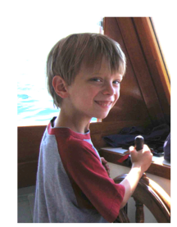____ none of the above

8. What two specific features does this creature have in common with all other primates but no other mammals besides primates?

__________________________________________

__________________________________________

9. Provide the correct axis labels for the diagram below to the right.

X-axis _______________________________

Y-axis _______________________________

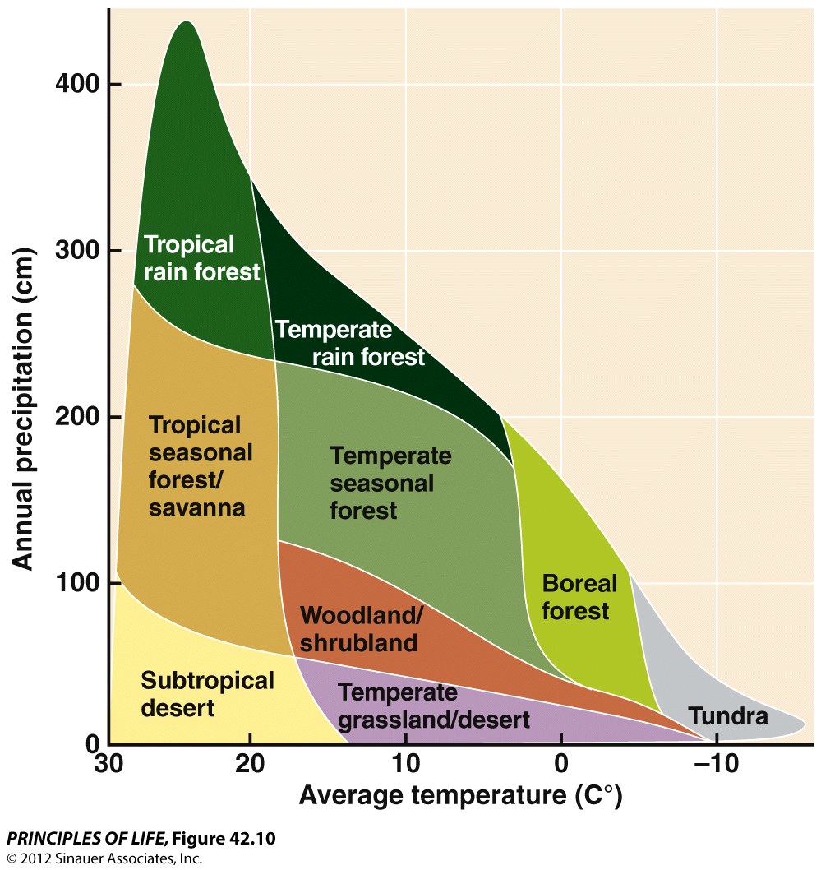

10. The oldest known fossils of members of the genus *Homo* are approximately X years old

____ 20,000

____ 200,000

____ 2,000,000

____ 20,000,000

____ 200,000,000

____ 2,000,000,000

11. Which of the following complicates the definition of, or application of the definition of “species?”

___ Sometimes when two populations are diverging it is hard to determine whether they should be considered different species.

___ Reproductive isolation cannot be directly tested for fossil species.

___ A species of Galapagos finches resulted from the mating of two birds that biologist agree were different species, and yet different species are not supposed to be able to produce fertile offspring.

___ All of the above.

___ None of the above.

12. Which of the following taxa (species or group of related species) has caused all the others to be threatened with extinction?

____ gorillas

____ humans

____ chimpanzees

____ gibbons

____ orangutans

____ lemurs

13. Besides lacking labels and difficulty distinguishing shading in grey scale, and the distortion of a flat map, what is wrong with this map?

14. Which of the following provide evidence consistent with the endosymbiont hypothesis for the origin of eukaryotes?

____ Mitochondria have DNA

____ Chloroplasts have DNA

____ Both bacterial and chloroplast DNA are circular, rather than linear like human chromosomal DNA

____ All of the above are consistent with the endosymbiont hypothesis.

____ None of the above is true. The endosymbiont hypothesis has been rejected.

15. The skeleton called “Lucy” is an example of an individual

___ *Homo erectus* that lived about 25,000 years ago.

___ *Homo naledi* recently discovered in South Africa.

___ An Australopithecine that lived about 4.5 million years ago.

___ A female *Homo neanderthalis* that lived about 2 million years ago.

___ None of the above.

16. The Cambrian explosion

_____ refers to a period about 550 million years ago when eukaryotes became much more diverse.

_____ refers to a period when a tremendous number of volcanoes spewed oxygen gas into the atmosphere.

_____ was the explosion caused by the asteroid that led to the extinction of the dinosaurs.

_____ refers to a predicted atmospheric event that could be caused by too much methane outgassing from below tundra permafrost as a result of melting due to global climate change.

_____ none of the above.

17. Ocean upwelling occurs where:

_____ tectonic plates collide under the ocean to form undersea mountain ranges.

_____ onshore winds cause a slight rise in sea level as water driven toward shore “piles” up near the shore. Precise, satellite-based height measurements can detect this upwelling.

_____ deep ocean water rises to the surface as winds blowing from the shore to the ocean move surface water away from the shore.

_____ unusually low gravitational forces do not “pull” water down as forcefully as in other areas.

_____ All of the above.

_____ None of the above.

18. Which of the following is not a misconception about evolution?

_____ Evolution occurs randomly.

_____ Humans are no longer evolving.

_____ Genetic drift can cause evolution.

_____ Individuals always get better adapted through evolution.

_____ Species are distinct natural entities, with a clear definition, that can be easily

recognized by any careful observer.

_____ All the above.

_____ None of the above.

19. The most recent common ancestor of humans and another ape occurred about

_____ 50,000 years ago

_____ 500,000 years ago

_____ 5,000,000 years ago

_____ 50,000,000 years ago

_____ 500,000,000 years ago

_____ 5,000,000,000 years ago

20. Label the arrows on the adjacent diagram. Write clearly. (6 points total)

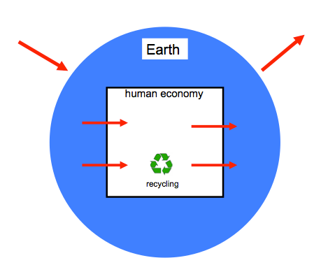

21. Mammals radiated about

____ 65,000 years ago

____ 650,000 years ago

____ 6,500,000 years ago

____ 65,000,000 years ago

____ 650,000,000 years ago

____ 6,500,000,000 years ago

22. Which of the following ecosystem services is generated by a boreal forest but not by a tar sand mine?

____ oxygen gas production

____ rain

____ fertile soil

____ cycling of elements

____ clean water

____ ultraviolet light shield

____ all the above

23. Bill McKibben’s statement that bears are like golden retrievers now refers to the circumstance that

____ bears have become tame due to frequent interactions with humans.

____ the survival of both species (and others) depend on our decisions.

____ humans have artificially selected bears just as they have artificially selected golden retrievers.

____ bears and golden retrievers have similar diet preferences.

____ all the above

____ none of the above

24. The earliest primates occurred about

____ 65,000 years ago

____ 650,000 years ago

____ 6,500,000 years ago

____ 65,000,000 years ago

____ 650,000,000 years ago

____ 6,500,000,000 years ago

25. From the perspective of consequences for the biota (living things), the greatest change in the conditions on the planet since the origin of life was

________________________________________________________________

26. Which of the following statements about biomes is false?

_____ Shrubs dominate chapparal.

_____ Grasses dominate savannas and temperate grasslands.

_____ Coniferous trees dominate boreal forests.

_____ Tundra typically lacks trees.

_____ None of the above because all the above are true.

27. Explain in one sentence the relevance of this diagram.

~~

28. True or false? Within-group differences among [human] individuals account for more than 90% of human genetic variation while differences among major groups constitute only a few percent.

_______ true ________ false

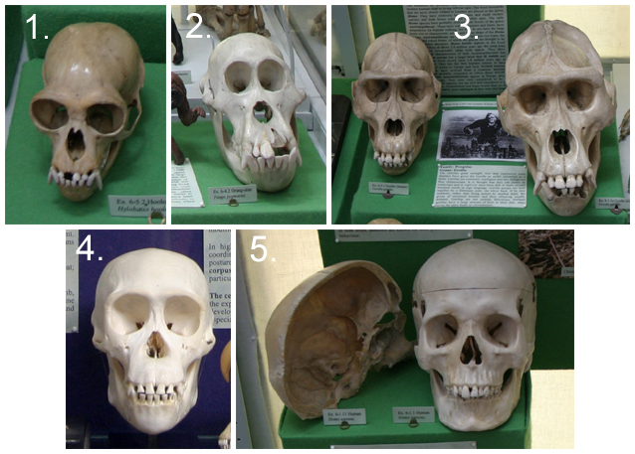29. Skull # 3 is a

____ human

____ gorilla

____ orangutan

____ chimpanzee

____ gibbon

____ lemur

____ space alien

30. In one sentence, what was my point in showing the following diagram? Note that the caption refers to figure 1 A and B but only B is reproduced here so you can ignore the explanation of Figure 1A.

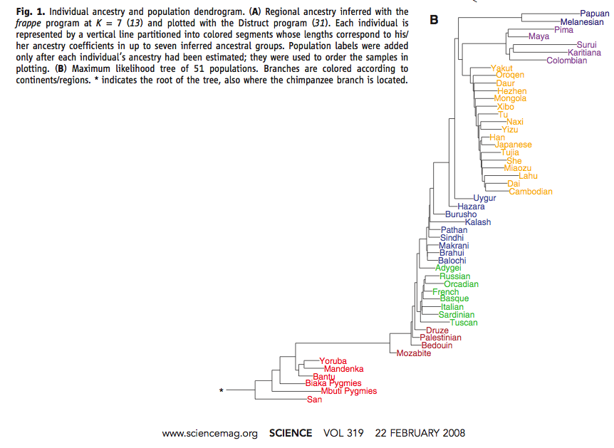

31. Describe a sequence of events creating new populations that would result in an evolutionary tree that looks like this. (6 points)

Population A Population B Population C Population D